

St. Michael’s School

Administration of Medication Policy

St. Michael’s School

Administration of Medication Policy

Introductory Statement

This policy is formulated in accordance with guidelines issued by the Primary Schools Managerial Bodies and the Irish National Teachers Organisation.

The policy has been further developed and reviewed by a sub-committee of the Board of Management comprising of the Principal, Teacher’s Representative, Parents’ Representatives, members of the In-School Management Team and also by representatives from the Parents Committee. Dr. Moya O’Beirne has been involved in the initial draft of this policy.

The Administration of Medication Policy should be read in conjunction with the School Information Booklet and with other relevant policies, e.g. Substance Use Policy, Policy on Tours/Outings etc.

Copies will be available on request to parents/guardians and a copy of this policy is found in the ‘Policies’ folder located in all classrooms. In addition, a copy will be available on the ‘Aladdin’ website for access by staff.

Medication in this policy refers to oral medicines i.e. liquids, tablets and inhalers administered by mouth only, topical creams or lotions and Epi-pens.

Rationale and Background

While the Board of Management has a duty to safeguard the health and safety of pupils when they are engaged in authorized school activities this does not imply a duty upon staff members to personally undertake the administration of medicines.
It is school policy that children who are ill should not attend school until the illness has resolved. When administration of medication is required, every effort will be made to accommodate pupils’ needs. It must be remembered that staff administering medication are non-medical professionals and are doing so in a voluntary capacity.

Relationship to Characteristic Spirit of the School

In accordance with St. Michael’s School Mission Statement, we commit ourselves to “provide a secure, healthy and caring environment which values the uniqueness of each person”. To this endeavour, it may be necessary that medication be administered to pupils. This policy establishes the protocol which is to be followed when such a situation arises.
Aims

The aims of this policy are to:

- Ensure that the needs of pupils who require administration of essential medication during the school day are met, in line with best practice.
- Ensure compliance with relevant legislation.
- Protect staff by ensuring that any involvement in medication administration complies with best practice guidelines.

Objectives:

The objective of this policy is to outline procedures that the school will follow when administering medication to pupils.

Guidelines / Procedures

Medicines should only be taken to school when essential, that is, where it would be detrimental to a child’s health if the medicine were not administered during the school day. Non- prescription medications will not be stored or administered in the school, with the exception of pain relief for menstruation (see page 6, paragraph on pain relief). St. Michael’s School will only accept medicines that have been prescribed by a medical professional. Pupils are not permitted to carry non-prescription medication in schools. If found such medications will be confiscated and parents/guardians will be contacted.

Parents/Guardians must ensure that the School is made aware in writing of any medical condition suffered by their son/daughter.

Prescription medication for our pupils can only be stored/administered in the school following a written request from the Parents/Guardians to the Board of Management (Appendix 1). In doing so, the Board of Management must determine if the medication is such that a staff member can administer the medication.
The Board of Management reserves the right, after due consideration, to refuse the request to administer medication.

Where a pupil is suffering from a life-threatening condition, parents/guardians must outline clearly, in writing, what can and can’t be done in a particular emergency situation, with particular reference to what may be a risk to the pupil.

Procedure to be followed by Parents/Guardians who require the administration of medication for their children:

- Parents/Guardians must write to the Board of Management requesting the Board to authorize staff member(s) to administer the medication by completing the “Request of Administration – Information and Consent” form (Appendix 1), summarising the essential information (this will also include a letter from the GP and a copy of the prescription) to allow school staff safe administration of medication.

- The Board will check all documentation is in order before approval is granted.
This ‘Request of Administration-Information and Consent form’ contains the following information:
- Parent/Guardian’s full name, address and contact number
- The pupil’s full name
- The pupil’s address if different from above
- The exact dosage and time of administration
- The circumstances in which medication is requested to be given by the staff member
- Any known allergies.
- GP name, address and telephone number.
- Whether the pupil should be responsible for self-administering his/her medication in the presence of the person designated by the Board of Management
- The procedure to be followed in the administration and storing of the medication
- A copy of the prescription.
- A letter from the GP/Consultant
- Signed consent to administer the appropriate medication
- Signature of Parent/Guardian

It is helpful, where clinically appropriate, if medicines that are prescribed in close frequencies are enabled to be taken outside of school hours. Parents could be encouraged to ask the prescriber about this. It is to be noted that medicines that need to be taken three times a day could be taken in the morning, after school hours and at bedtime.

Parents/Guardians are further required to indemnify the Board of Management and staff members in respect of any liability that may arise regarding the administration of prescribed medications in school. An Indemnity Form (Appendix 2) will be provided to Parents/Guardians to be completed to this effect. The Board of Management will inform the school’s insurers accordingly.

Details must be completed on the Epilepsy Information Sheet (Appendix 3), the Asthma Information Sheet (Appendix 4), the Anaphylaxis Information Sheet (Appendix 5), the Diabetes Information Sheet (Appendix 6) and/or the Information Sheet re other medical condition or special instructions re administration of medication (Appendix 7) if the pupil suffers from the(se) condition(s) or if special instructions must be adhered to.

Where permission has been given by the Board of Management for administration of medicine the smallest possible dose should be brought to school, preferably by the parent/guardian, with clear written instructions for administration, giving the name of the pupil and a copy of the prescription. All medication should be in its original packaging (trade name, generic name, expiry date and dosage should be clearly legible).

In the event that the parent/guardian is unable to come to the school, medication should be given to the Bus Escort who will store it securely. This medication will be handed into the school office where a handover sheet for the medication (Appendix 8) will be signed by both parties.

Parents/Guardians are responsible for the provision of medication and should keep account to ensure that medication is available.

All medication must be in its original container as dispensed by a pharmacist and include the prescriber’s instructions for administration.

In the event that medications arrive to the school in inappropriate packaging, such medications will not be administered by staff during school hours. Parents will be contacted and advised accordingly.

Parents/Guardians should ensure that inhalers required by asthmatic pupils are sent to school and these will be readily accessible at all times of the school day. In the event of a pupil needing to take inhalers without the completed required documentation, parents will be contacted and asked to come to the school. The school cannot be responsible for medication administered without complete adherence to this policy.

A Teacher/Special Needs Assistant should not administer medication without the authorization of the Principal. Any staff member who agrees to take responsibility for medicines must be adequately instructed and trained in the administration of same. No staff member takes on a responsibility that he/she is not competent to carry out. Allianz: Risk Management.

Prior to any medication being administered Parent/ Guardian must meet with the Principal to explain the procedure and to confirm the information on the personal medication plan matches the prescription.

Changes in prescribed medication (or dosage) should be notified immediately to the school with clear written instructions of the procedure to be followed in storing and administering the new medication. These should be accompanied by a copy of the new prescription.
Parents are required to provide a telephone number where they may be contacted in the event of an emergency arising.

Parents/Guardians should ensure that these procedures are clearly understood before submitting any request to the Board of Management.

Requests for administration of medication should be renewed at the beginning of each school year and /or as need arises.

Procedure for Safe Storage of Medication
Medication administered daily by the Principal/School Secretary will be stored in a secure/locked press in the Office. Emergency medication will be kept in the pupil’s school bag and the bag will travel with them. During break times the bag will remain in the pupil’s classroom. A second supply will be requested and stored in the locked First Aid Press in the foyer, the key for which is hanging in the key press. If such emergency medication is administered parents will be notified by telephone by the relevant staff member.

For pupils in receipt of regular medications parents are advised to provide a weekly/monthly supply of medication to the school. This must be in a properly labelled container /package. Under no circumstances are staff permitted to transfer medication from one container to another. Where a pupil needs two or more prescribed medicines, each should be in a separate container.

Inhalers should be kept in the pupil’s bag and the bag will travel with them. During break times the bag will remain in the pupil’s classroom.

St. Michael’s school will not accept medicines that have been taken out of the container as originally dispensed nor make changes to dosages on parental instructions.

Staff are responsible for making sure that medicines are stored securely.

Procedures for Staff members for administration of medications

All pupils who require administration of medications will have a personal medication plan (Appendix 9) which will be completed by parent/guardian in conjunction with GP/Consultant. Plans will be placed in each pupil’s file. Each plan will be accompanied by an up to date prescription which is attached to the plan.
The Personal Medication Plan must detail all medications required by the child and any emergency/ medications as required.

In the event that Emergency medication is required staff can only administer medications as approved by the Board of Management. Please see Appendix 3.2 for the Protocol relating to Action to be taken in the event of an Epileptic Seizure. In the event that an emergency arises and staff are unable to administer the necessary medications, parents will be contacted and emergency services will be contacted as necessary.

Where a change has occurred in medications an updated personal medication plan and prescription is required. The Principal will draw a line diagonally across the previous medication plan and prescription sheet and date it to indicate it is no longer in use and place on record in the pupil’s file.

The staff member is responsible for ensuring that the following is correct before administering any medication:

- Pupil’s name is correct
- The following information on the medication label and prescription/medication plan correlate:
  - Pupil’s name
  - Medication name
  - Dosage
  - Route and form
  - Time to be given
- Check that the medication has not already been administered by another staff member.
- The pupil where possible comes to the office or designated area to receive medication. A staff member administers medication and remains with pupil until the medication is taken.
- Medication is administered by the relevant staff member and witnessed.
- Once medication has been administered, the administrating staff member and witness signs in the appropriate space on the medication recording chart (Appendix 8)
- In the event that a pupil refuses medication, it must be documented and parents notified
- Staff should not dispose of medicines. Date expired medicines or those no longer required for treatment should be returned to the Parent/Guardian, either directly or via the Bus Escort.

Pain Relief
If a pupil brings pain relief with her to school to address menstruation pain, the medication should be self-administered where possible and must be given into the office on arrival to school. The bus escort should be informed by the parent/guardian that medication is in the child’s bag. A note must be provided by the parent/guardian for the school, stating the exact dosage which may be taken and at the time it is to be taken at. A telephone call is made by the school secretary/Principal/Deputy Principal to confirm the contents of the note and instructions. The Board of Management is informed at the next Board of Management meeting.

The school accepts no responsibility when a pupil brings medication to be taken during the course of the school day without parental consent and/or notifying staff.

In the event of a specific and/or isolated injury/procedure resulting in a child requiring pain relief during the school day, parents/guardians are welcome to come to the school to administer said pain relief to the child at the required time.

Procedure in the event of a Medication error occurring
The Board of Management encourages the reporting of medication incidents to ensure pupil safety and to have a means of assessing and improving medication processes.
Staff who become aware that a medication error has occurred should
- Notify the principal/ deputy who contact the parent/guardian and inform them of the incident.
- The school would seek advice from medical emergency services/ Poisons Unit in Beaumont Hospital (01 8092566 or 01 8379964) and follow advice given
- Ask parents to contact GP.
- Continue to observe pupil until parent arrives and in the event of an adverse reaction causing concern contact emergency services.
- Document the medication incident on incident reporting form and maintain in pupil’s file.

Procedure in the event of Missing Medication

In the event of medication going missing the following must occur:
- Principal is informed and incident report completed.
- Principal must immediately initiate local enquiries/ search to establish the facts related to the medication incident.
- A review of control measures will take place and additional controls put in place if deemed necessary.
- The incident of unaccounted for or missing medication must be reported to the next Board of management meeting.
- A copy of the incident report is stored according to local procedures for file management.

Roles and Responsibility

Medications required to be administered on a daily basis will be done so by the Principal/School Secretary. Medicines should be self-administered by the pupil if possible under direct supervision of the Principal/School Secretary, and witnessed by class SNA or other staff member. Medications should not be administered without a witness present.

A staff member can administer medication / emergency medication when necessary or when pupils are on school outings, once all incidences of same are recorded in the Medication Administration Form (Appendix 10, available in the school office) and done in the presence of a witness.

Emergency medication will be administered by the staff member in the presence of another staff member, and where possible the Principal/Deputy Principal should be present.

Pupils who require the use of an inhaler must inform a staff member before using this medication. All information with regards to inhalers must be recorded on the Asthma information sheet (Appendix 4) to be completed by parents/ guardians. Once administered an account of this must be recorded on the ‘Medication Administration Form’ specific for this pupil. This sheet will be kept in the class blue folder along with I.E.Ps etc.

Education/ Training of Staff

Staff will receive training and input from suitably qualified persons on the management of Safe Administration of Medications. This will be reviewed on a regular basis and/or as need arises. A record of training signed by staff will be maintained.

Policy Links

Health, Safety & Welfare Statement
Child Protection Policy
Substance Use Policy
Policy on Managing Chronic Health Conditions
School Outing Policy
Life long Illness / Medical Conditions Policy
Accident/Illness Policy
Lunchtime Policy

Success Criteria

This policy will ensure the effective and proper administration of prescribed medication to pupils. A record of same will be available from the office.

Timeframe for Implementation & Review

This policy will be put in place with immediate effect and will be reviewed at the beginning of each school year or as necessary with the Principal having responsibility for co-ordinating this review. This review will include all procedures, including how they are working in practice.

Ratification and Communication

In draft form this policy was firstly given to members of the In-School Management Team, extended to other members of this team in November 2008. When due account was taken of any amendments, this policy was presented the Board of Management on 20th November 2008. The policy was amended and was represented to the Board for ratification on 9th February 2009. Recommendations made at this meeting were included and agreement on its ratification reached. The policy was revised again in September 2011. This policy was further amended in consultation with all staff in November 2016 and presented to the Board for ratification on 22nd February 2017. Further to the amendments to the Enrolment/Admissions Policy, this policy was updated and brought to the Board at a meeting on 27th March, 2019.

Signed: Sr Bernadette Carron Date: 27.03.2019
Chairperson, Board of Management
Appendix 1
Request for Administration of Medication to Pupils- Information and Consent
Request to the Board of Management of St. Michael’s Special School.

Parents/Guardians name(s): ________________________________
________________________________
Address: _________________________________________________________
_____________________________________________________________________
Telephone numbers: ________________________________
________________________________
Emergency contact no.: ________________________________

Child’s name: _________________________________
Date of Birth: ________________________________
Address (if different from above):_________________________________________
____________________________________________________________________

Name of medication: ________________________________
Dosage: ________________________________
Time to be given: ________________________________
Under what circumstances should medication be given:________________________
Condition for which medication is required: _________________________________
My child CAN/CANNOT self- administer this medication under direct supervision.

GP name: ________________________________
GP Address: __________________________________________________________
GP Phone no.: _____________________________
1 I/We the parents/guardians of ______________________________________ ask the Board of Management to allow a member of staff to give medication to my child ______________.

2. I/We enclose a letter from Dr. ___________________________ stating:
- Why the medication is needed
- Name of medication
- Time the medication should be administered
- Procedure to be followed for the safe storage of medication
- Dosage to be administered
- Copy of the prescription

3. Should there be any change in medication, I/We will write to the Board of Management notifying them of same.

4. I/We understand that the school’s insurance will be notified of this arrangement.

5. I/We understand that information about my child’s medical condition and treatment will be shared with relevant school staff and in the event of an emergency with the GP or other medical personnel.

Signed:_______________________________ Date:___________________
Parent/Guardian

Signed:_______________________________ Date:___________________
Parent/Guardian

Appendix 2:
Indemnity Form

I/We_________________________________________________________________
Parents/Guardians of ___________________________________________________
will not hold St. Michael’s School or any staff member liable for any consequences, both present and in the future, arising from the administration or failure to administer medicines or other forms of treatment, provided this was done in accordance with the guidelines of the protocol on the ‘Administration of Medication Policy’ of St. Michael’s School.

Signature of Parent(s)/Guardian(s):

1st Signature: _________________________________

2nd Signature: ________________________________

Signature: _________________________________
Principal/School Secretary

Date: __________________________________

Appendix 3

Epilepsy Information Sheet

Pupil’s Name: ______________________________

Date first diagnosed with Epilepsy

Description of what the seizure looks like

Warning sign (aura), if applicable

How long the seizure last

How long of a rest is usual after a seizure?

What first aid may be required?

Frequency of seizures and pattern, if any?

Any other relevant information which you think the school should have with regards to your child’s condition.

Signed: _________________________________
Parent/Guardian

Date: _________________________________
Appendix 3.1

Individual Epilepsy Emergency Plan

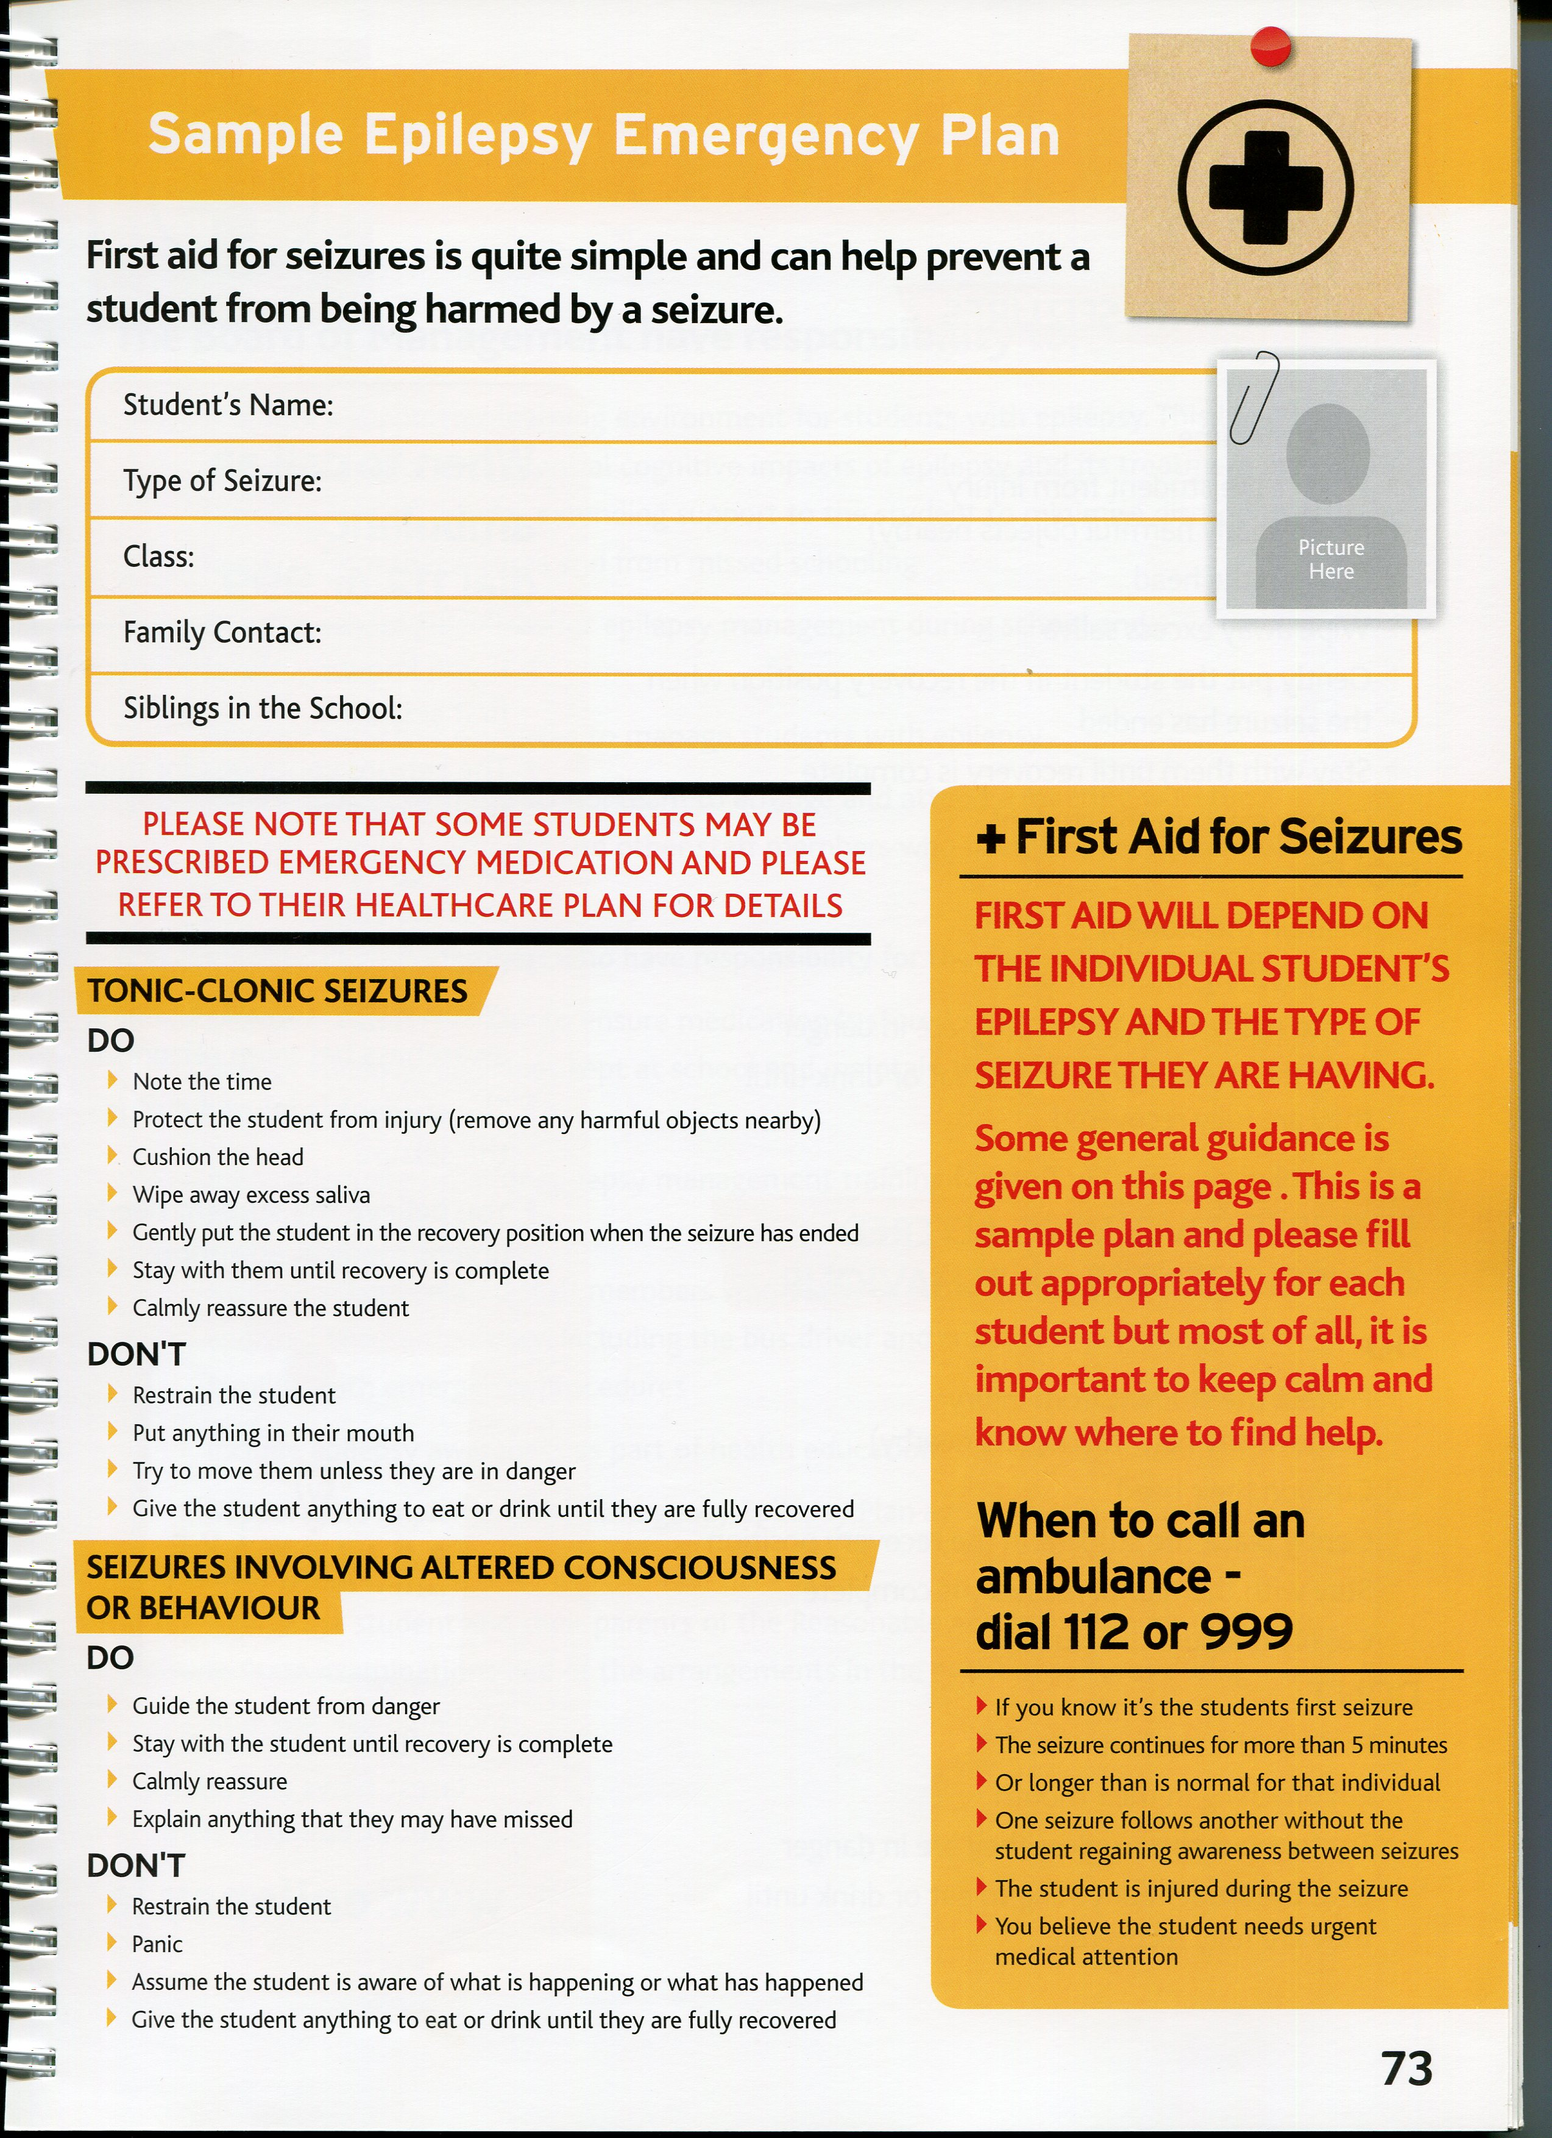
Appendix 3.2
EPILEPSY
ACTION TO BE TAKEN IN THE EVENT OF A SEIZURE

A first responder on site is to alert the class teacher or teacher on duty immediately and begin to time the seizure.

The first responder will attend to the pupil with the support of the teacher in class or on duty.

The teacher will redirect all other staff and pupils away from the scene.

The Principal is to be notified immediately in the event of a seizure. In the absence of the Principal, the Deputy Principal, school management team is to be notified.
DO | DO NOT
- KEEP CALM  - Ensure their head is protected from hard surfaces. If not use clothing, i.e. rolled up coat/jumper or your hand.  - Loosen clothing around the neck to keep their airway clear  - Time length of seizure | - Do not move the child unless they are near harmful objects  - Do not put anything in the child’s mouth  - Do not try to hold the child’s tongue  - Do not try to hold down the child during the seizure

Pupil emergency medication should be administered as per Personal Medication Plan.

Call an ambulance if any of the following occur:

- Seizure is longer than what is usual for the pupil after protocols have been followed (emergency medication, where provided, should be administered)
- Seizure is unusual for the pupil and no protocols are in place
- You are concerned for the child’s safety
- Evidence the child is choking, unable to breathe, injured
- If one seizure follows another and the child does not regain consciousness in between seizures.
- IF IN DOUBT PHONE

After the seizure:
- Check the child is breathing normally
- Remain with the child and reassure him/her when they regain consciousness
- Inform the parents
  - Describe the seizure
  - Length of the seizure
  - How the child was after the seizure
  - Record in accident/illness book
Appendix 4

Asthma Information Sheet

Pupil’s Name: ______________________________

Date first diagnosed with Asthma

Details of inhaler/medication being used, if any

If an inhaler is used, have you supplied one to the school, clearly labelled with your child’s full name?
Where should this inhaler be stored or should it be on the child at all times?

How often must the inhaler be used?

Is there a certain sport/activity that may bring on the need to use the inhaler?

Can the child use the inhaler him/herself?

If no, when should a staff member administer the inhaler? What does an attack look like for your child? How will a staff member know it is necessary to administer the inhaler?
Emergency contact details
Any other relevant information which you think the school should have with regards to your child’s condition.

Signed: _________________________________
Parent/Guardian

Date: _________________________________
Appendix 4.1

Individual Asthma Emergency Plan

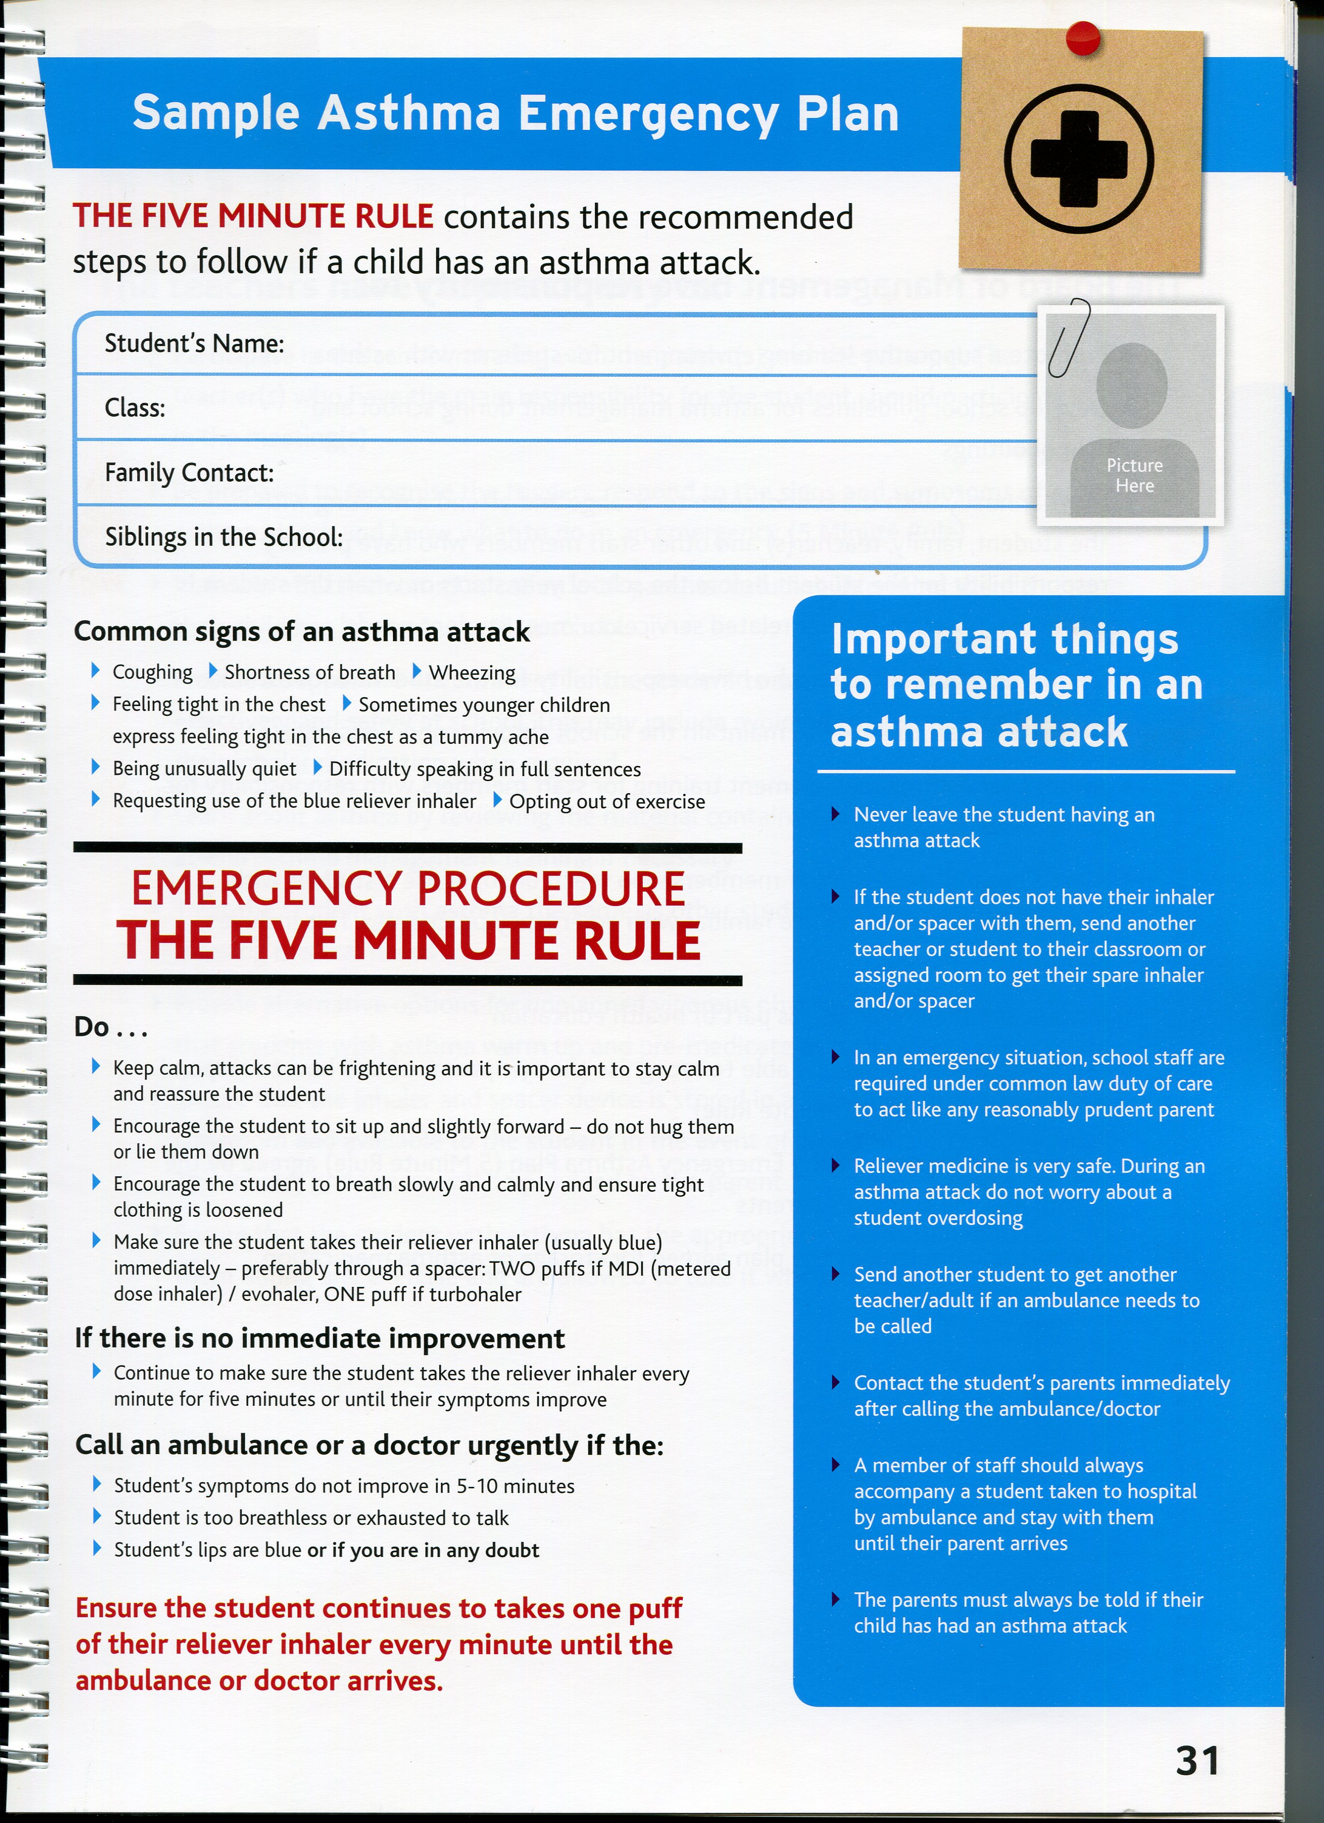

Appendix 5

Anaphylaxis Information Sheet

Pupil’s Name: ______________________________

Date first diagnosed with Anaphylaxis

Description of what the allergic reaction looks like

Allergic to

Warning sign, if applicable

Normal procedure following administration of emergency medication?

What first aid may be required?

Previous history regarding administration of emergency medication

Any other relevant information which you think the school should have with regards to your child’s condition.

Signed: _________________________________
Parent/Guardian

Date: _________________________________
Appendix 5.1
Individual Emergency Anaphylaxis Plan

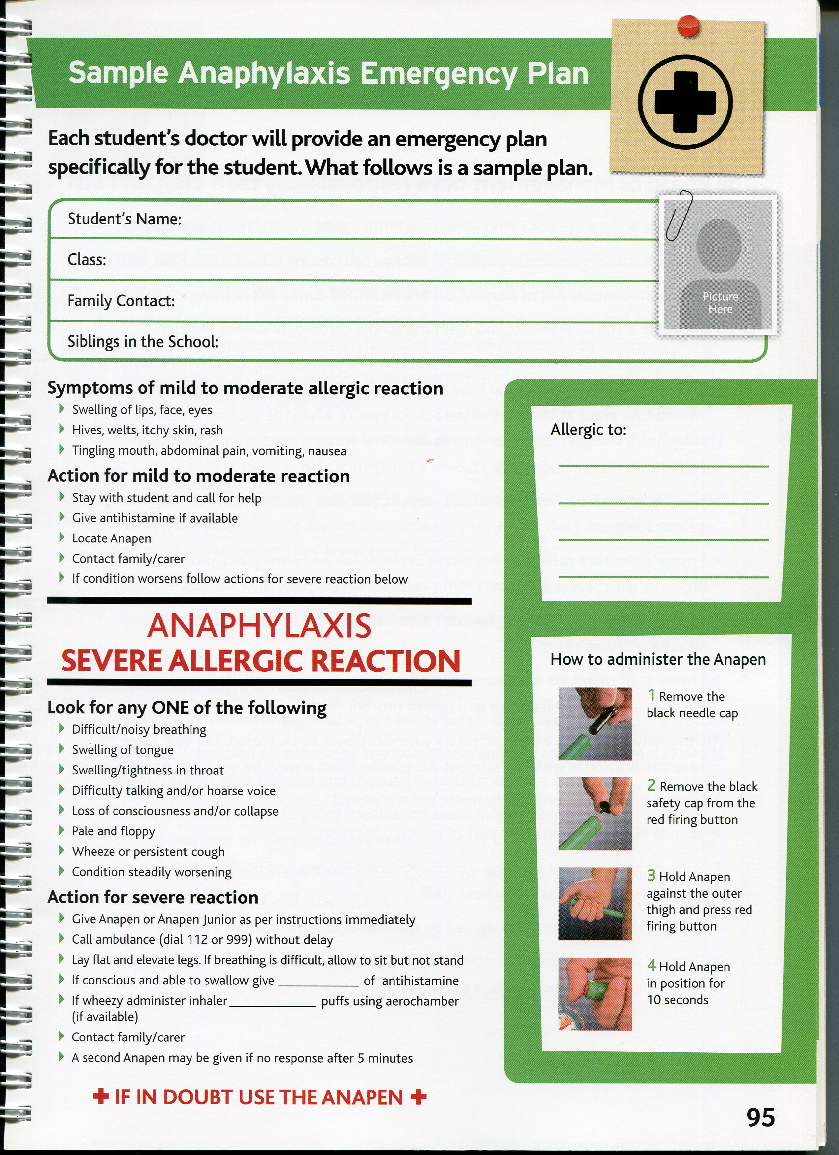
Appendix 6

Diabetes Information Sheet

Pupil’s Name: ______________________________

Date first diagnosed with Diabetes

Type of diabetes

Indicators of low blood sugar, if applicable

Normal readings

High reading – over _________

Low reading – under ________

Protocol for readings, frequency, time to be read etc.

Instructions if reading is low

Instructions if reading is high

Any other relevant information which you think the school should have with regards to your child’s condition.

Signed: _________________________________
Parent/Guardian

Date: _________________________________
Appendix 7

Information Sheet re other medical condition or special instructions re administration of medication

Pupil’s Name: ______________________________

Details:

_____________________________________________________________________

_____________________________________________________________________

_____________________________________________________________________

_____________________________________________________________________

_____________________________________________________________________

_____________________________________________________________________

_____________________________________________________________________

_____________________________________________________________________

_____________________________________________________________________

_____________________________________________________________________

_____________________________________________________________________

_____________________________________________________________________

_____________________________________________________________________

_____________________________________________________________________

Signed: _________________________________
Parent/Guardian

Date: _________________________________

Appendix 8
Medication Handover Sheet
Date | Name of Pupil | From  Signature | To  Signature
Appendix 9:
Personal Medication Plan (placed in each pupil’s file where applicable)
Name of Pupil: ___________________ Date of Birth:_________________
Known Allergies___________________________________________________

Date commenced | Medication(s) prescribed | Dose | Time to be administered

Prescribed By: ____________________________________
Reason for Medication:_____________________________

Any other details (Possible side effects) _________________

How is medication taken, any special precautions e.g. before or after food etc. ___________________________________________________________________

Can self administer under supervision Yes _____ NO ___

Signed by: ____________________________________________Parent/Guardian
Date :_______________________________
Appendix 10
Medication Administration Form
Pupil’s Name: ____________ Date Of Birth:_____________

Date | Medication Administered by (Signature) | Dose | Time Given | Witness Signature

In the event that medication is refused, please complete form including Date and name of medication. Insert “Refused” in section under Time and sign.

